How important is data analytics for a business strategy.

**Introduction**

Nowadays most big companies has been using data to guide at every step of decision making, however when is the best time to implement data analysis to assist every sector of a company and how can this data collaborate in a company's results?

“Analytics is about tracking the metrics that are critical to your business. Usually, those metrics matter because they relate to your business model where money comes from, how much things cost, how many customers you have, and the effectiveness of your customer acquisition strategies” (Croll and Yoskovitz, 2013a)

Croll (2013) mentions how important is to know about metrics since this this metrics can impact directly on the results of this company. In another words, every step is necessary collect data to make sure about strategy and future decisions.

**Objectives**

*This project is going to provide information in order to understand how important is implement the data analysis in a company decision, this project going to present an prove that have the right information can help to grown a business in a very fist steep.*

*A entrepreneur can decide if the best option is open a restaurant or a clothes store for example, using the a simple information that how is the environment to make this decision. (ALTERAR )*

**Problem Definition:**

It is important to present how important is data analysis for buidyng a business

“OS DADOS ESTÃO DIMINUINDO DEVIDO AS POLITICAS DE PRIVACIDADE”

-QUAIS FERRAMENTAS DEVEM SER USADAS PARA ACOLETA DE DADOS.

-APRESENTAR DADOS SOBRE CRECIMENTO DE EMPRESAS E COMO SERIA BENEFICO ETC.

**Scope**

In this semester initially is going to be present how data can help in a beginner of one business, also how the data analysis can help in business strategy in a short and long term.

For the second semester is going to be present data from small business that are using data or note and how use data can improve the sales and success of a business.

**Data Sources:**

The data in these resources is going to be collected from public bases, about small and big companies that are using data on your strategy. Also is going to be present some cases about the data could help and how can help in a business evolution.

According to Data camp (“What is Data Analysis?,” n.d.) data can be used for many sections of a business, data is a important tool to handle with business and strategy. Follow some examples that how data analysis can be used for a company:

Data analysis helps the company to take its next steps based on facts and not just intuition, for example through data analysis a company is able to know how a particular product or service is performing and thus know how to adjust strategies to improve product development, create insights, improve marketing campaigns, among other possibilities.(“What is Data Analysis?,” n.d.)

Just as for a large company, the same technique can be applied, but on a large scale (big data), identifying patterns and improving strategies for the next steps. The fact is that companies that use this tool to their advantage have a much greater competitive advantage compared to companies that do not use that. (“What is Data Analysis?,” n.d.)

A seguir podemos verificar de forma simplificada como funciona a analise de dados dentro de uma empresa.

“The more customers you have, the more data you can gather, and that data, when analysed with machine-learning tools, allows you to offer a better product that attracts more customers.” (“When Data Creates Competitive Advantage,” n.d.)

Como citado acima:

-apresentação de empresas sando dados:

According to the data presented in the graph below. It is correct to say that, for example, Ireland in 2021 presented the number of 19% of companies in Ireland make use of CRM (Customer Relationship Management) system for the collection of consumer data for marketing purposes.

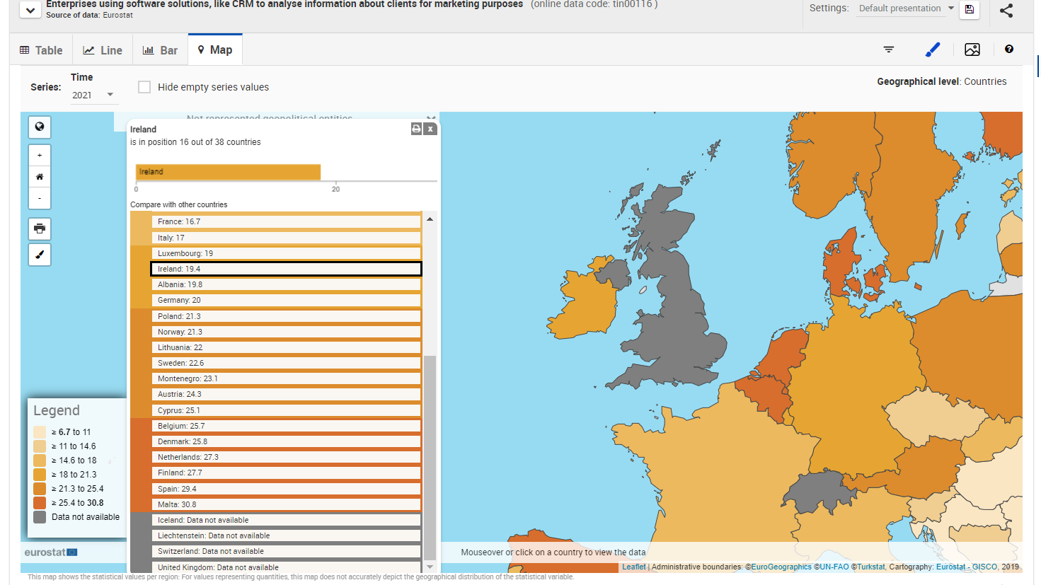

* In 2021, there were 369,030 enterprises in the Irish business economy.

Although the above data is relevant, another important fact is that in 2015 the number of companies that used data for marketing strategies was 27%, that is, 8% more than the percentage presented in 2021

This fact has occurred due to the increase in privacy regulations that prevent the capture of data through cookies, for example, due to this it is also necessary to implement new capture methods like Customer Data Platforms (CDPs), for example. ( Statista Research Department, 2024)

<https://books.google.co.uk/books?hl=pt-BR&lr=&id=mIk6x8WNQAwC&oi=fnd&pg=PR17&dq=lean+analytics+use+data+to+build+a+better+startup&ots=iDdugAA9Ki&sig=r3QWswJDpEEstsV94I9WKo3pfg4&redir_esc=y#v=twopage&q&f=false>

-IDEIAS

Falar sobre diminuição de dados devido a política de privacidade*

Solução? Conclusão.

You need to lie to yourself, but not to the point where you're jeopardizing

your business.

That's where data comes in.

Your delusions, no matter how convincing, will wither under the harsh

light of data. Analytics is the necessary counterweight to lying, the yin to

the yang of hyperbole. Moreover, data-driven learning is the cornerstone of

success in startups. It's how you learn what's working and iterate toward

the right product and market before the money runs out. (Croll and Yoskovitz, 2013b)

https://books.google.co.uk/books?hl=pt-BR&lr=&id=mIk6x8WNQAwC&oi=fnd&pg=PR17&dq=lean+analytics+use+data+to+build+a+better+startup&ots=iDdugAA9Ki&sig=r3QWswJDpEEstsV94I9WKo3pfg4&redir_esc=y#v=twopage&q&f=false

Book with One Author In text Citation: Montgomery (2013, p.57) states that… Reference List: Montgomery, C.A. (2013) The strategist: be the leader your business needs. London: HarperCollins.

References? Example: Smith, J. (2010) The Art of Referencing. London: Academic Press.

Book with One Author In text Citation: Montgomery (2013, p.57) states that… Reference List: Montgomery, C.A. (2013) The strategist: be the leader your business needs. London: HarperCollins.

According to Domegan and Fleming (2007, p.13)….

Reference livro citacao

Domegan, C. and Fleming, D. (2007) *Marketing research in*

*Ireland: theory and practice*. 3rd ed. Dublin: Gill & Macmillan.

Ebook

Reference

Domegan, C. and Fleming, D. (2007) *Marketing research in Ireland: theory and practice*. 3rd ed. Gill &Macmillan. Available at: <https://search.ebscohost.com/login.aspx?direct=true&db=cat07932a&AN=cct.1648&site=eds-live>(Accessed: 16 November 2021).

WEBPAGE FULL REFERENCE

Format:

Author (person or organization). Year of publication (or most recent date page created or revised) .Title of the page or document. Available at: (URL) (Accessed: Day Month Year).

Croll, A., Yoskovitz, B., 2013a. Lean Analytics: Use Data to Build a Better Startup Faster. O’Reilly Media, Inc.

Croll, A., Yoskovitz, B., 2013b. Lean Analytics: Use Data to Build a Better Startup Faster. O’Reilly Media, Inc.

What is Data Analysis? An Expert Guide With Examples [WWW Document], n.d. URL https://www.datacamp.com/blog/what-is-data-analysis-expert-guide?form=MG0AV3 (accessed 10.22.24).

When Data Creates Competitive Advantage [WWW Document], n.d. URL https://hbr.org/2020/01/when-data-creates-competitive-advantage?form=MG0AV3 (accessed 10.22.24).

Verificar referencias ebook